AUTOPAY NOW AVAILABLE

The Town of Rising Sun now has AUTOPAY available for your monthly utility bill (water, sewer, trash) when using your debit or credit card as the payment method.

Create a login or use your current login at risingsunmd.org – PAY MY BILL
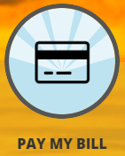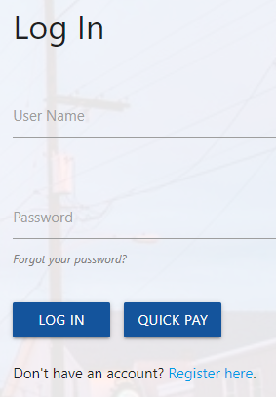

Add your credit or debit card as your payment method:
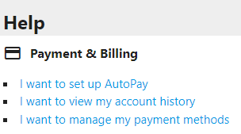

Set Up AutoPay:
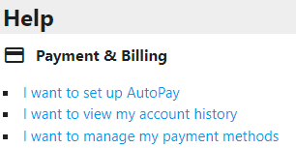

The payment will be processed on or about the 8th of every month. If the 8th falls on a weekend or holiday, payments will be processed the next business day.

PERKS OF AUTOPAY

- Never miss a payment – Payments made on time.
- Convenience – Payment made automatically on time and securely without logging in to the website.
- Savings – payments are processed during the discount period each month.
- No Fee - No service fee charged to process the payment.
- Peace of Mind – Avoid stress of shut-off if you forget to make the payment.

