**How to Register for the Utility Billing Portal (Steps 1-6)**

1. Go to the Rising Sun web page, www.risingsunmd.org and select PAY MY BILL

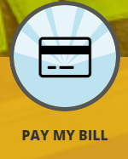

1. At the bottom of the Log In box, click on register. You may also use the register tab at the top of the screen. 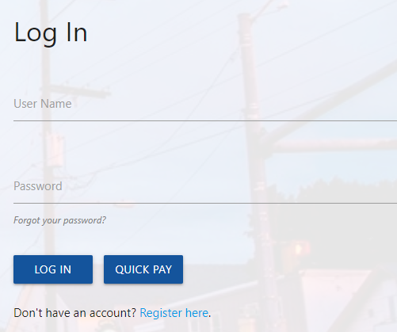



1. You must enter the Master account number on the page that comes up and the phone number

associated with the Master account. Click search. *If you are renting or if your correct phone number

is not on file, call the Town Hall for assistance.

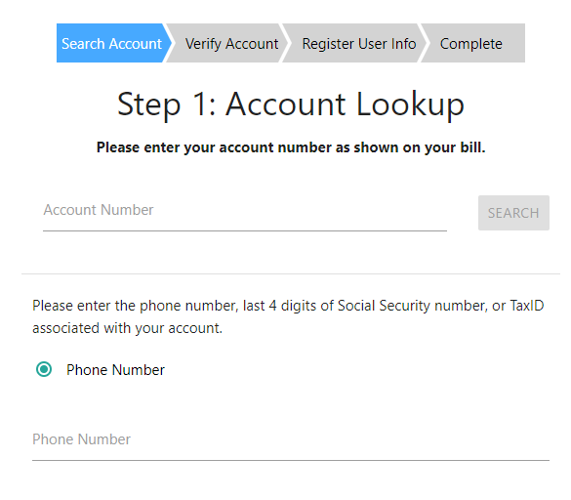 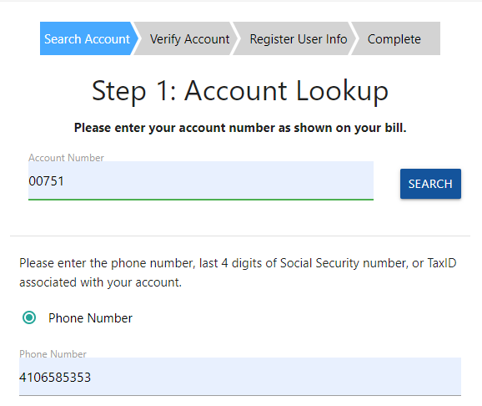

1. The next page verifies your account, click on yes this is my account.

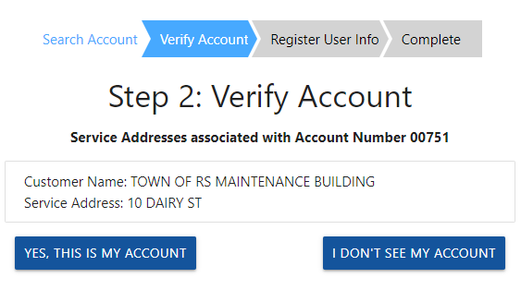

1. Next page, create a user name and password, confirm password and add your email. Click on Register 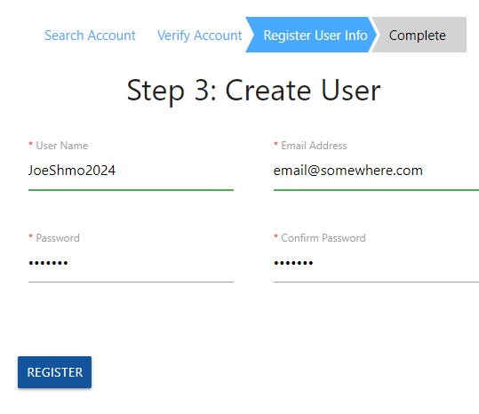
2. Be sure to save your information someplace safe as we do not have access to your password.

Click Log In

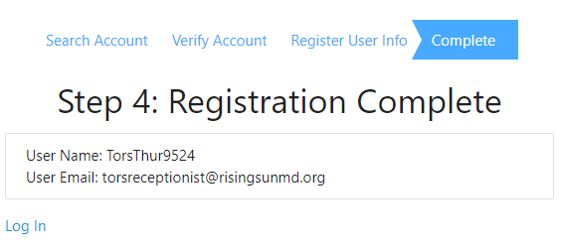

email@somewhere.com

Joeshmo2024